KAMLA NEHRU INSTITUTE OF TECHNOLOGY, SULTANPUR



## Session 2022-2023

**MINI PROJECT REPORT ON**

## *EDGE AVOIDING ROBOT USING ARDUINO*

|  |  |  |
| --- | --- | --- |
| **Submitted by:-** |  | **Submitted to:-** |
| Harsh Singh | 21428 | Mr. S.P. Gangwar |
| Harsh Yadav | 21430 | (Department of Electronics Engineering) |
| Muskan Dhanwani  Pranshu Srivastava  Saksham Soni | 21440  21444  21449 |  |

TABLE OF CONTENT

1. **Acknowledgement**
2. **Introduction**
3. **Working Principal**
4. **Block Diagram**
5. **Circuit Diagram**
6. **Component Used**
7. **Code**

1. **Application**
2. **Conclusion**

# ACKNOWLEDGEMENT

This project report is something we are extremely proud of and have worked extremely hard to make a reality. This project effort is the result of many people's contributions, without which it would not have been possible. We would like to start by expressing our sincere gratitude to esteemed professor Mr. Vinay Kumar for giving us all the direction we needed to finish the project.

Introduction

One of the most crucial components of mobile robotics is edge avoidance. Without it, robot motion would be extremely limited and brittle. This concept suggests creating a robotic vehicle with built-in intelligence that can self-direct anytime an edge is in its route.

This architecture can be used to create an edge-avoidance robotic vehicle that moves utilising ultrasonic sensors. The desired operation is carried out by an AT mega 328P microcontroller. Any edge in front of it is detected by an ultrasonic sensor, which then sends an instruction to the microcontroller. The microcontroller instructs the robot to move in a different direction by activating the motors that are connected to it by a motor driver, depending on the input signal it receives.

## WORKING PRINCIPLE

The HC-SR04 ultrasonic sensor uses a sonar system to measure distance to an object, similar to how bats do it. From around 2 cm to 400 cm, or 1 foot to 13 feet, it provides outstanding non-contact range detection. Neither sunshine nor dark objects have an impact on its operation. The signal is brief and high frequency and is sent by the ultrasonic sensor. If they identify an item, they return the echo signal that is input to the sensor through the Echo pin by reflecting it.

First, the operator sets the Trigger and Echo pins to a low beginning position before moving the robot forward. The echo pin will supply the microcontroller with input as low as an edge is detected (the distance from ground increases). Calculating the time of the distance of the floor from the edge is done using the pulse in function. Every time the function starts timing as it waits for the pin to go high, timing is terminated when the pin goes high. If a complete pulse was not received within the timeout, it returns the pulse length in microseconds. The timing has been established, which means it provides the pulse's length and will reveal timing issues in shorter pulses. Pulses of a duration of 10 microseconds to 3 minutes are considered. It translates into a distance once the time has been established. If an edge is present, the robot will turn to the left and slow down if the distance to the object is just moderate. The pace of the robot will decrease if the edge is close by, and it will turn backward before moving left or right. An Arduino development board, on which a microcontroller is mounted, was used to construct this robot.

The motor driver board (pins 8, 9, 10, and 11) connects the Arduino board to the DC motor and powers the actuators. When a barrier that can be identified by ultrasonic sensors is present in its route, the robot's movement will stop. The microcontroller receives time in length as an input from ultrasonic sensors for subsequent action.

# CIRCUIT DIAGRAM

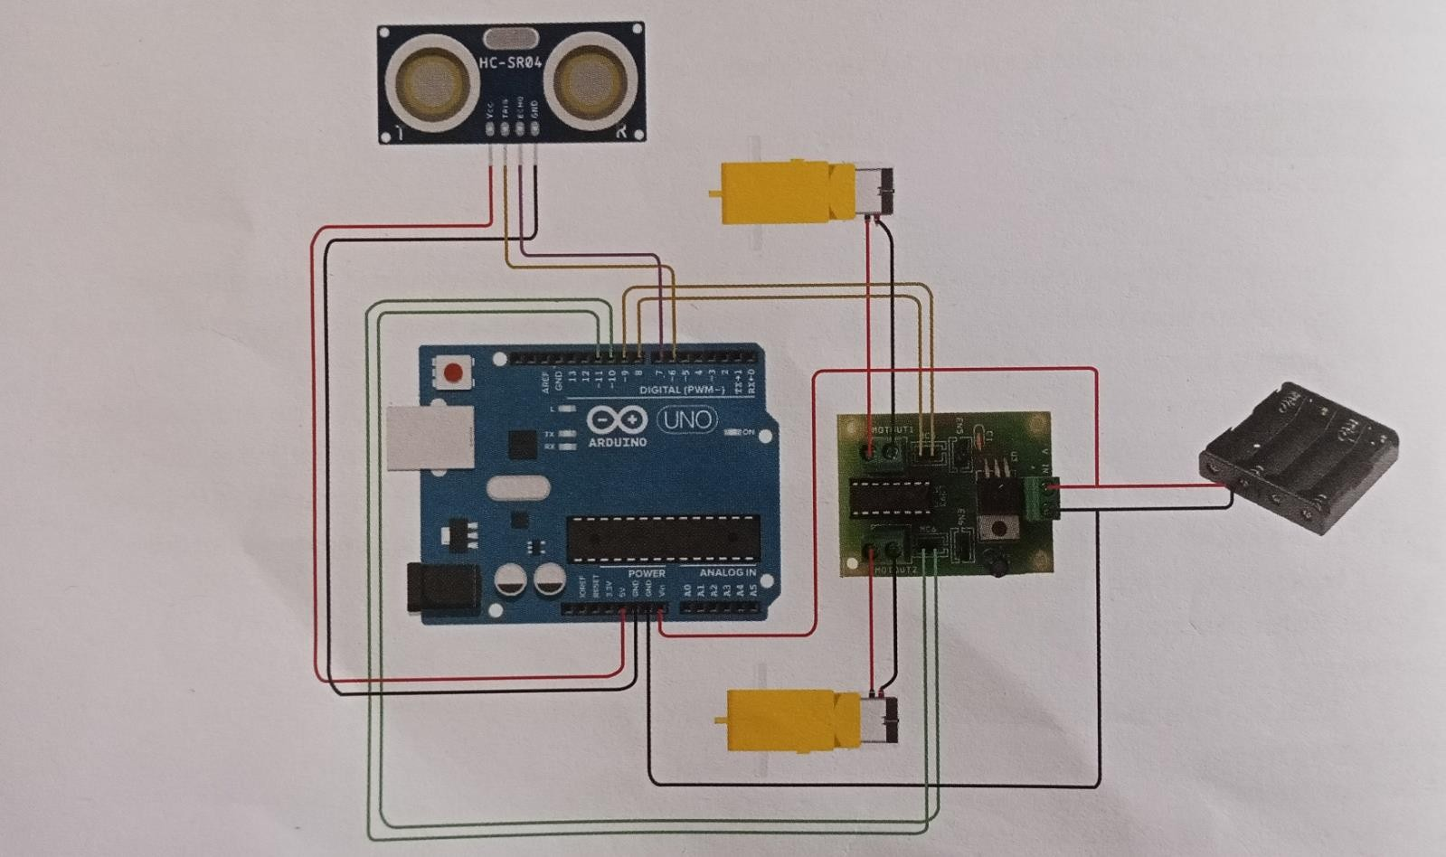

## COMPONENT USED

* Battery Connector
* Ultrasonic Sensor – HC – SR04
* Arduino Uno
* Motor Driver IC – L293D
* Geared Motors x 2
* Cardboard
* Power Supply
* Battery Holder

## COMPONENT DESCRIPTION

***ARDUINO UNO***

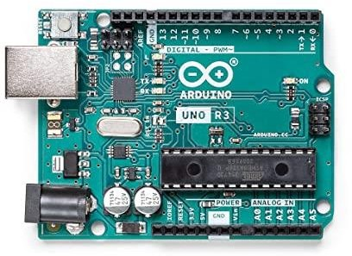Arduino Uno is an AT mega 328p Microcontroller based prototyping board. It is an open source electronic prototyping platform that can be used with various sensors and actuators. Arduino Uno has 14 digital I/O pins out of which 6 pins are used in this project.

## *ULTRASONIC SENSOR*

The HC-SR04 uses non-contact ultrasound sonar to measure the distance to an object, and consists of two ultrasonic transmitters (basically speakers), a receiver, and a control circuit. The transmitters emit a high frequency ultrasonic sound, which bounce off any nearby solid objects, and the reciever listens for any return echo. That echo is then processed by the control circuit to calculate the time difference between the signal being transmitted and received.

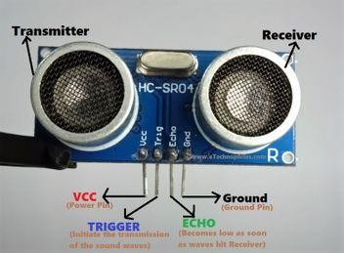

## *MOTOR DRIVER IC L293D*

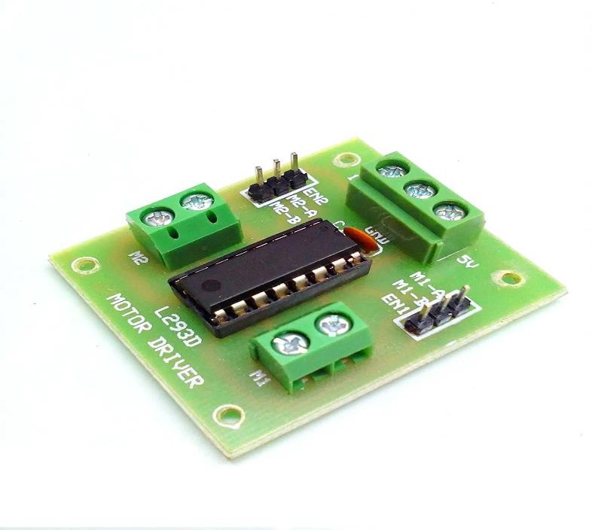The L293D is a popular 16-Pin **Motor Driver IC**. As the name suggests it is mainly used to drive motors. A single **L293D IC** is capable of running two [DC motors](https://components101.com/motors/toy-dc-motor) at the same time, also the direction of these two motors can be controlled independently.

# ***GEARED MOTOR***

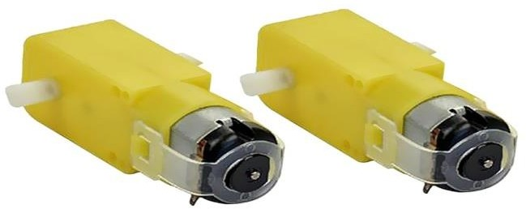A **geared motor** is an electric motor and a power reducer combined into a single unit that reduces the number of revolutions but increases the torque of the operating shaft. Such gears for electric motors are often used in modern machines and mechanisms, it is universal for many types of equipment.

CODE

#include<NewPing.h>

#define MLa 8

#define MLb 9

#define MRa 10

#define MRb 11

#define TRIGGER_PIN 6

#define ECHO_PIN 7

#define MAX_DISTANCE 500

NewPing sonar(TRIGGER_PIN, ECHO_PIN, MAX_DISTANCE);

void setup(){

Serial.begin(9600);

pinMode(MLa, OUTPUT);

pinMode(MLb, OUTPUT);

pinMode(MRa, OUTPUT);

pinMode(MRb, OUTPUT);

}

int Distance = 0;

void loop(){

delay(50);

Distance = sonar.ping_cm;

Serial.print(“Ping: ”);

Serial.print(Distance);

Serial.println(“Distance”);

if(Distance>4){

Serial.println(“Edge Detected”);

digitalWrite(MLa, LOW);

digitalWrite(MLb, LOW);

digitalWrite(MRa, LOW);

digitalWrite(MRb, LOW);

digitalWrite(MRa, LOW);

digitalWrite(MRb, LOW);

delay(300);

digitalWrite(MLa, LOW);

digitalWrite(MLb, HIGH);

digitalWrite(MLb, HIGH);

digitalWrite(MLb, HIGH);

digitalWrite(MRa, LOW);

digitalWrite(MRb, HIGH);

delay(500);

digitalWrite(MLa, LOW);

digitalWrite(MLb, LOW);

digitalWrite(MRa, LOW);

digitalWrite(MRb, LOW);

delay(300);

digitalWrite(MLa, HIGH);

digitalWrite(MLb, LOW);

digitalWrite(MRa, LOW);

digitalWrite(MRb, LOW);

delay(500);

}

else{

digitalWrite(MLa, HIGH);

digitalWrite(MLb, LOW);

digitalWrite(MRa, HIGH);

digitalWrite(MRb, LOW);

}

}

APPLICATION

* + This module can be integrated into the Robot and will help to deal with unwanted incidents. In the case of multi-story building construction, different building materials falling from unfinished floors are quite normal. Such products can be transported very easily across the edge.
  + This module can be equipped in the Robot and it will help to face uninvited accidents.

In the case of multistoried building construction, it is pretty common, falling various construction materials from incomplete floors. These materials can be carried very efficient through the edge and obstacle avoiding robot. There are a lot of disable people depended on wheelchair. This idea can be implemented in wheelchairs as it can detect obstacle and edge autonomously.

CONCLUSION

Along order to recognise and avoid edges in its route, this research created an edge-avoiding robot. The robot's software counterpart helped to communicate with it so that it could send parameters for directing movement. The robot is constructed on the Arduino platform for data processing. Three ultrasonic distance sensors, which offered a larger field of detection, were used for edge detection. After the initial loading of the code, the robot is completely autonomous and doesn't need any user input to function. We have a lot of factors to improve upon in order to maximise the robot's movement. However, the majority of these suggestions will require more time and resource.